**Rochester Youth Development study**

Article is a Rochester youth development study- done in April 1999

<https://www.ojp.gov/pdffiles1/fs99103.pdf>

Key points

1. Family influences delinquency - Attachment and involvement greatly influences delinquency. Poor parenting increases the likelihood of a child turning to delinquency. The effect and impact of family decreases as children grow up and become independent.
2. School - weak school commitment and poor school performance is associated with drug use and delinquency. School success was associated with resilience. High risk of dropping out.
3. Peers behavior- engaging in delinquent behavior had strong reciprocal effects, increasing associations with delinquent peers and the formation of delinquent beliefs.
4. Gang membership and delinquency- Although they represented only one-third of the Rochester sample, gang members accounted for 86 percent of serious delinquent acts, 69 percent of violent delinquent acts, and 70 percent of drug sales. - also increases teenage pregnancy
5. Youth with guns - Boys who owned guns for “protection” owned pistols, sawed-off rifles, and sawed-off shotguns and were much more likely to engage in a wide array of criminal behaviors.
6. Structural position- social class and community effects delinquency.

**Fatherlessness In Relation to Delinquency**

Reference Article Link : <https://kidsimprisoned.news21.com/blog/2020/07/how-fatherlessness-contributes-to-juvenile-delinquency/>

**Summary**: Homes where the father is absent are more likely to experience poverty and financial hardships. In addition children are more likely to have behavioral issues like depression, and engage in illegal activities like using drugs and drinking alcohol. Youth of color are more likely to experience fatherless homes.

Website works to increase fathers involvement : <https://www.fatherhood.org/father-absence-statistic>

**Young mothers and their effect on child delinquency**

**Link**: <https://www.researchgate.net/publication/229563486_The_delinquency_of_children_born_to_young_mothers_Results_from_the_Rochester_Youth_Development_Study>

**Summary of what was found**: It was found that children born to mothers who began childbearing at a young age were more prone to general delinquency, violence, and arrest than were children born to mothers who began childbearing when they were older.

**The idea of Father and Mother complexes, slang terminology “Mommy issues” and “Daddy Issues”**

**Father Complex**

Daddy issues is an informal phrase for the psychological challenges resulting from an absent or abnormal relationship with one’s father, often manifesting in a distrust of, or sexual desire for, men who act as father figures. ( dictionary.com)

**Mother Complex**

In general, mommy issues are **the psychological challenges you deal with as an adult that result from your childhood relationship with your mother or another adult female figure in your life**. (healthline)( Talkspace.com)

Often Sons will look for their “mother” in a personal relationship with a female.

**Both** the father and mother complex affects child delinquency as it affects their development. Children can develop mental health illnesses and unhealthy relationships with romantic partners.

[https://marripedia.org/effects_of_parents_on _crime_rates](https://marripedia.org/effects_of_parents_on_crime_rates)

Key points from article

* Maternal affection = allows for children to develop empathy ( mothers allow for maternal affection)
* Lack of maternal affection = behavior problems with children and an increase in delinquency

<https://marripedia.org/effects_of_maternal_attachment_on_crime_rates>

* Boys who are fatherless from birth are three times as likely to go to jail as peers from intact families, while boys whose fathers do not leave until they are 10 to 14 years old are two times as likely to go to jail as their peers from intact families.
* Teens in blended or divorced families tend to have more [behavioral problems](https://marripedia.org/effects.of.divorce.on.children.s.behavior), like using tobacco, binge drinking, weapon carrying, physical fighting, or sexual activity. Increase in delinquency.

**STATS on Youth Gang Involvement Taken From National Youth Gang Survey (Global)**

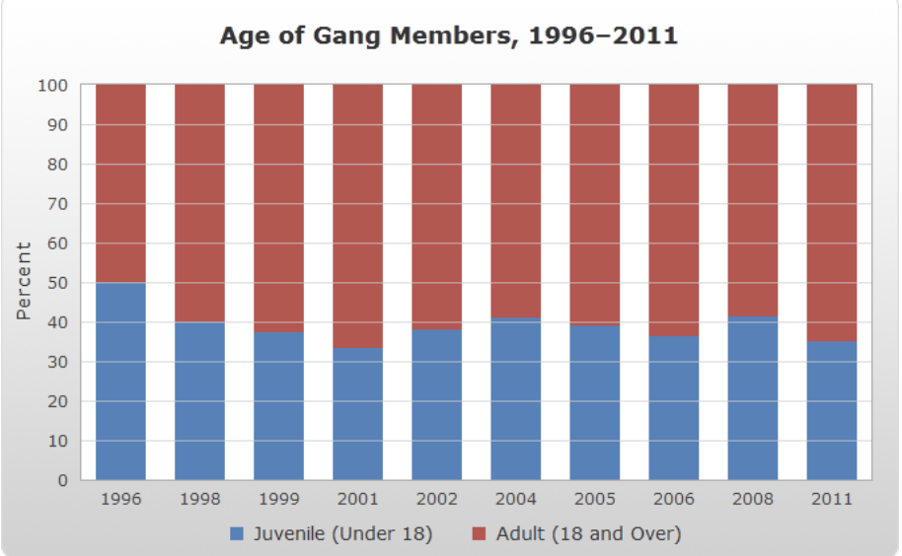

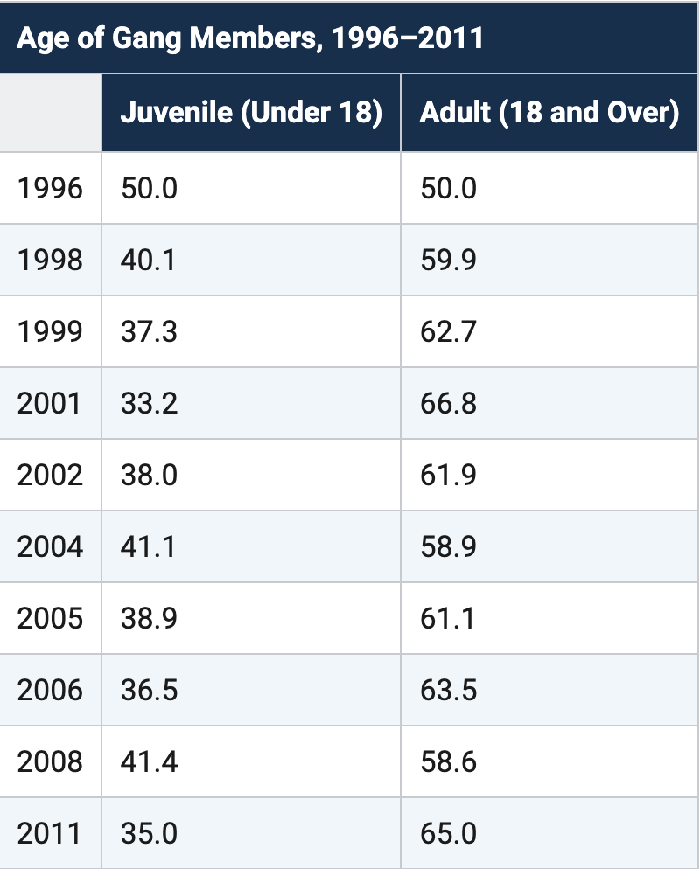

**Takeaways**

* Larger cities and suburban counties, which typically have long-standing gang problems, are more likely to report more adult gang members than juvenile gang members. (NYGS)
* Conversely, smaller cities and rural counties, whose gang problems are relatively more recent, are more likely to report equal proportions of juvenile and adult gang members.(NYGS)

**Gender of gang Members**

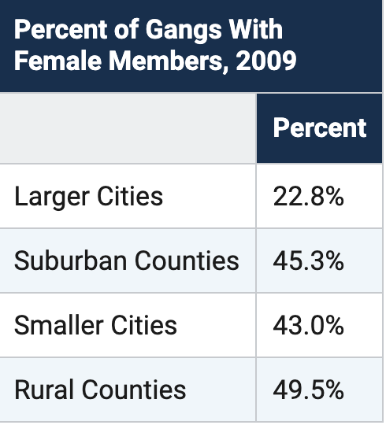

Female Gang Members, separated by cities/ counties

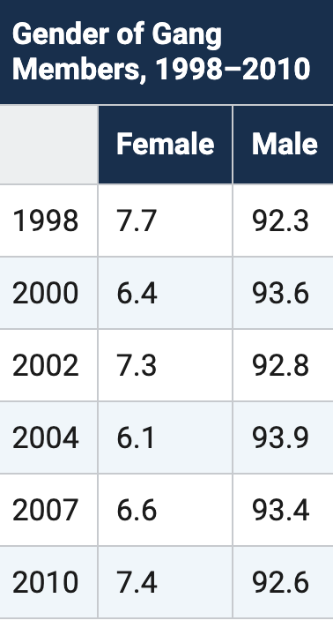

Males are more likely to be involved in Gangs than females.

**Race and ethnicity of Gang Members**

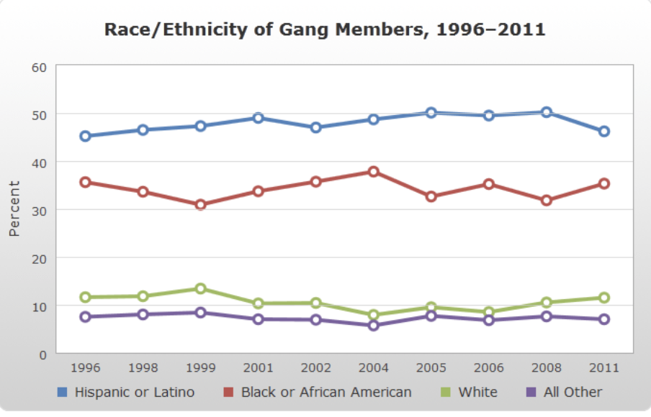

**Takeaways**

* 46 % of Gangs members are hispanic or latino
* 35 % of Gang members are Black/African American
* 11% are White
* 7 are other

**Separated by Area**

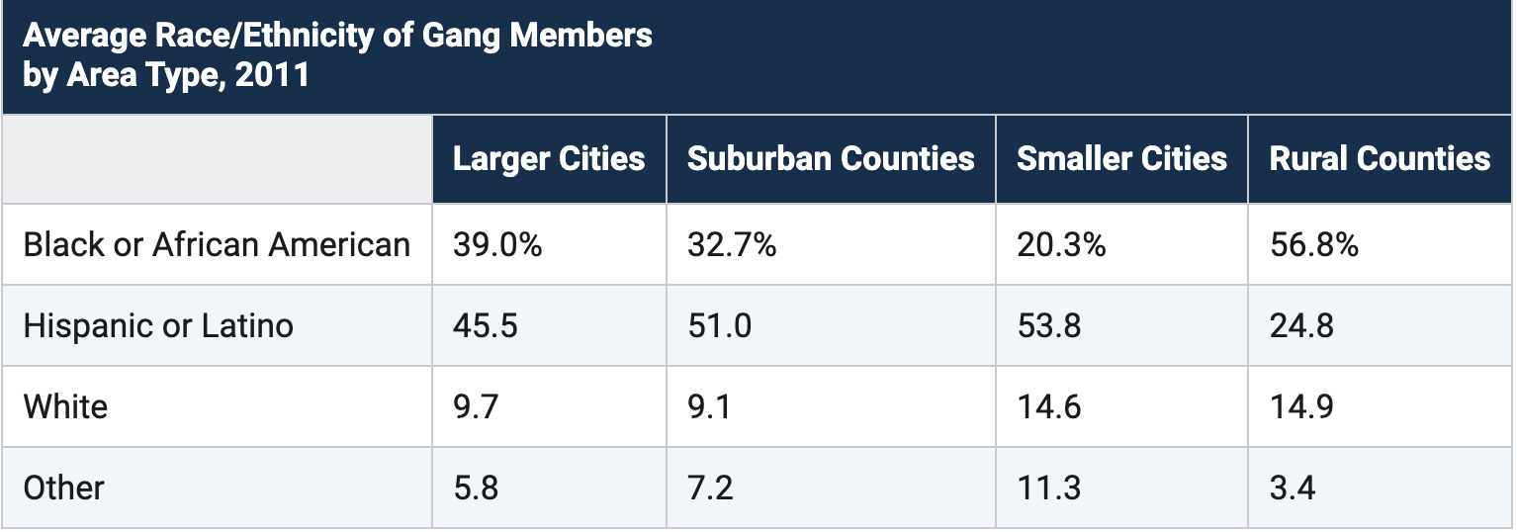

**Key takeaways**

* White gang member involvement increases when in Rural counties ( if they live within this type of county)
* White gang member involvement decreases when they are living in smaller / larger or Suburban areas
* Hispanic or latino member involvement is higher in larger/smaller and suburban counties but low in Rural county areas
* African American or black member involvement is lower within larger/smaller and suburban areas but high in Rural areas

Links

<https://nationalgangcenter.ojp.gov/survey-analysis/demographics#anchorgender>

<https://nationalgangcenter.ojp.gov/survey-analysis/measuring-the-extent-of-gang-problems>

**Rochester STATS on Youth in Gangs**

[**https://www.insideprison.com/regional_gang_activity_county.asp?ID=1884**](https://www.insideprison.com/regional_gang_activity_county.asp?ID=1884)

[**https://spectrumlocalnews.com/nys/rochester/public-safety/2022/02/23/new-youth-center-in-rochester-offering-safety-from-violence-on-the-streets**](https://spectrumlocalnews.com/nys/rochester/public-safety/2022/02/23/new-youth-center-in-rochester-offering-safety-from-violence-on-the-streets)

* **News article** discusses Gun violence in relation to teen gang relations. A new Youth Center made in Rochester, NY
* **Vazquez-Simmons states** : "When you look at young people who are already in the streets, who are already making money from gangs and drug dealing, the answer is usually their passion, what they love to do," said Santiago. "If they love to write music, that right there is the answer. I've been able to be blessed to mentor young people around my age, 17, 18, 19 and the way I've really focused on getting them out of the gangs, getting them out of the drug dealing, is by focusing on their passion and what they love to do."

**5 prompts ( writing assignment )**

1. What is one thing you are most passionate about and why?
2. What inspires you ?
3. What is one thing you regret the most?
4. One thing you are most proud of?
5. What issues do you believe are within your community ? How would you change this?

**Group activity** - getting to know other kids in similar situations and getting to share their stories.

Physical activities - sport games ( basketball, kick ball, ect )

**Post incarcerated links**

<https://sgp.fas.org/crs/misc/RL34287.pdf>

* Page 5-6 discusses recidivism and the rate at which someone reoffends
* Quote from text **“ ​​82.1% of released property offenders were rearrested, compared to 76.9% of drug offenders, 73.6% of public order offenders, and 71.3% of violent offenders”**
* The amount of reoffense is high.
* 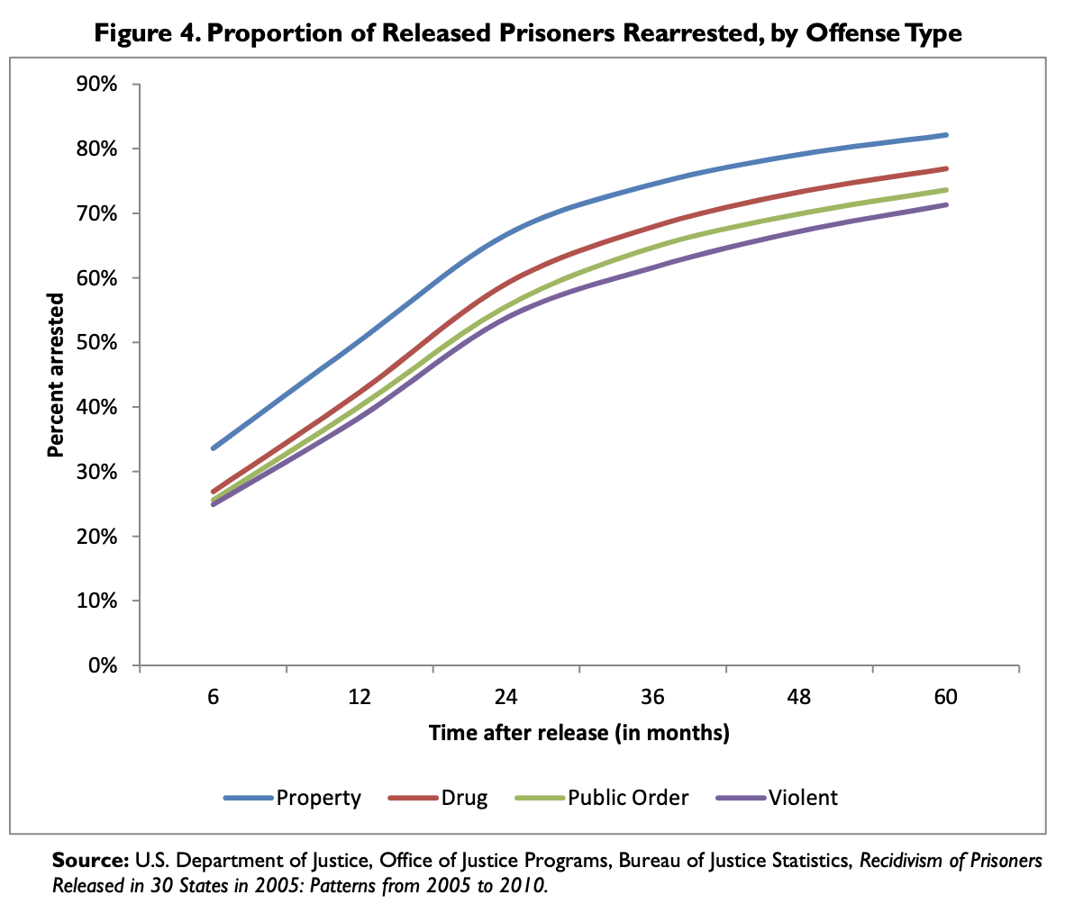
* More were rearrested for property crime than drug or violent crime.

**Recidivism can be measured differently**

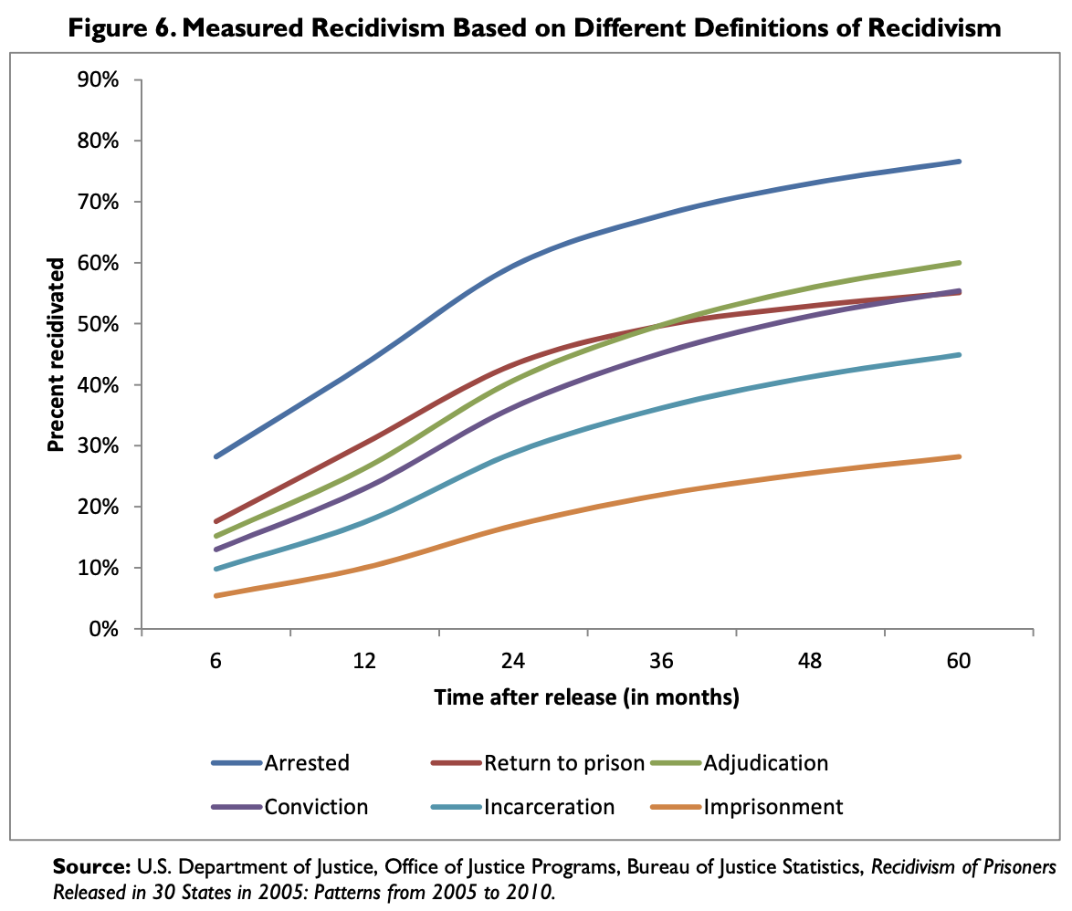

The table breaks down recidivism in groups of those who were Arrested, convicted, incarcerated,imprisoned, returned to prison, and adjudication.

**Post incarcerated link 2**

<https://www.prisonpolicy.org/blog/2022/02/08/employment/>

* This website provides insight on why offenders reoffend. The most common issue that arose was unemployment for those getting released from prison. Those who get employed get paid less than the general public.
* Lack of social welfare programs
* Post incarcerated people are set up to fail, most enter prison “poor” and leave prison in a worse predicament because jobs do not want to hire felons.
* 2021-2022 are turning toward post incarcerated groups to fill the labor shortages that covid caused. ( however they do not treat them greatly)

**Link of the Justice Bureau**

<https://www.census.gov/content/dam/Census/library/working-papers/2021/econ/ADEP-WP-2021-04.pdf>

* Tracks the employment of convicted felons
* Manufacturing companies and construction used to be the best option for those seeking employment and were known to help those provide for their family, but in present times they have not been doing so. ( these companies used to reduce recidivism)

**Post Incarcerated link 3**

<https://bjs.ojp.gov/library/publications/recidivism-prisoners-released-34-states-2012-5-year-follow-period-2012-2017>

* Stats are from 2012-2017
* 5 year period
* “Nearly half (46%) of prisoners released in 2012 returned to prison within 5 years for a parole or probation violation or a new sentence.”

**Post Incarcerated Link 4**

<https://bjs.ojp.gov/library/publications/recidivism-prisoners-released-24-states-2008-10-year-follow-period-2008-2018>

* Stats from (2008-2018)
* 10 year period
* “ 61% of prisoners released in 2008 returned to prison within 10 years for a parole or probation violation or a new sentence.”

**Reentry Program link**

<https://www.justice.gov/usao-wdwa/reentry-program>

* This link discusses what reentry is and the different types of programs there are.
* **DREAM Court** designed for drug offenders
* **Warrants Initiative** designed for helping “ local prosecutors to find solutions that both meet the goals of the local prosecution and allow the defendant to take advantage of BOP’s re-entry services.”
* **Community Partnership for Transition Services** designedto come together and make new effective reentry programs
* **Indiana County** was a 3 day workshop to hear reentry experts and make new programs for those leaving prison and to prevent reentry